Thermometer App

Software Requirements Specification

1.0

November 18, 2013

Ray Yi

Software Engineer

Prepared for

WUBS UI Thermometer Assignment

**Table of Contents**

1. General Description 1

2. Specific Requirements 1

2.1 Main View 1

2.2 Settings View 2

2.3 Web API 3

# 1. General Description

This document describes Software Requirement Specification (SRS) for the project Thermometer App. This project is for the WUBS UI Thermometer Assignment, the content of SRS is based on the problem description in that document.

Thermometer App is a web-based application, its main function is to show temperature on the default page, and with some indicators for freezing and boiling status. User can change these thresholds through settings, and those settings also include other attributes, such as temperature format (Fahrenheit and Celsius), and frequency of sending request to server to temperature from server.

# 2. Specific Requirements

Thermometer App is a single page application, its main view show temperature and some indicators, and refreshes it frequently. And there is another view to allow user to change settings for main view. And 1 more view to show threshold settings, it can also allow user update threshold values.

## 2.1 Main View

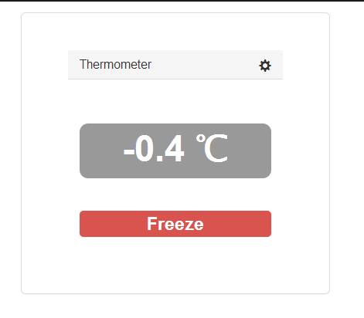

There are 3 rows in the main view,

1. Title bar, this row display title ‘Thermometer’, and there is config icon at right end, user click it to go to setting view to change settings.
2. Temperature row, this row display temperature, in Fahrenheit or Celsius format, and this temperature is refreshed frequently. The format can be changed in setting view. The refresh frequency can also be changed in setting view.
3. Indicator row, this row display threshold name if current temperature reaches any threshold, which is defined in setting view.

There are some rules for showing indicator:

1. Indicator only show when current temperature reach any threshold
2. In the first time of reach any threshold, show model overlay to warring user, and pause refresh temperature.
3. Each threshold has below attributes:
4. Threshold point, the temperature of threshold
5. Fluctuation range, if the temperature is in the range, the indicator keeps same.
6. Direction, it indicates the threshold was reached from a certain direction.
7. Our system may have multiple thresholds, we have 2 default thresholds, as below, and user can add/delete through setting view.
8. Freezing, its threshold point is 0, its fluctuating range is =/- 0.5, and no direction.
9. Boiling, its threshold point is 100, its fluctuating range is =/- 0.5, and no direction.
10. If temporary reaches to any threshold, we will show below model warning overlay. And its message is:
11. If the threshold has no direction, message is: it reachs ‘threshold name’ .
12. If the threshold has direction, message is: it reachs up/down to ‘threshold name’.

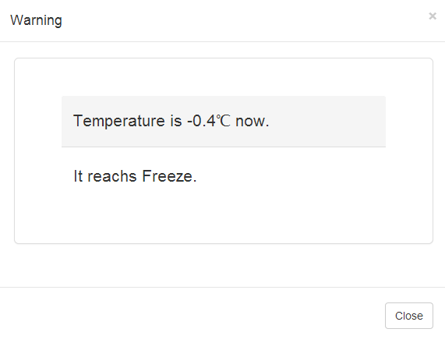

## 2.2 Settings View

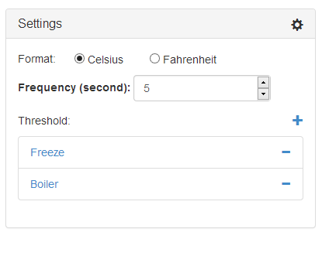

This view shows all settings, these settings allow user change behaviors of main view. They include:

1. The icon on right top corner, click it to go back to main view.
2. Format, switch temperature format between Fahrenheit and Celsius. Default is Celsius.
3. Frequency, it is decide interval seconds used by main view to retrieve temperature from server. Default is 5 seconds.
4. Thresholds list, this part display list of threshold item, when temperature changed, we go through this list to check if any threshold is reached.
5. User can add new threshold settings by click ‘+’, it will redirect to threshold view to allow user edit threshold settings:
6. Threshold name, default is NewName.
7. Threshold point, default is 0.
8. Fluctuation range, default is 0.5.
9. Direction, no value.
10. User can delete exist threshold by clicking ‘-‘ at end of each threshold settings.

## 2.3 Threshold View

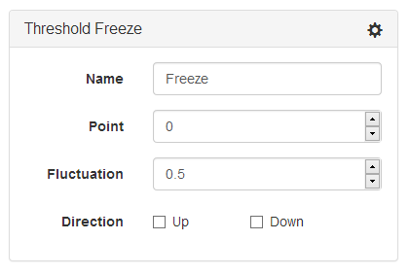

This view display single threshold details, it include:

1. Title bar, show threshold name,
2. Icon at top right corner, click it to back to setting view.
3. Threshold detail information include:
   1. Threshold name,
   2. Threshold point, the temperature of threshold
   3. Fluctuation range, if the temperature is in the range, the indicator keeps same.
   4. Direction, it indicates the threshold was reached from a certain direction.

## 2.4 Web API

We need web service to get temperature, for this application, this service will return random number to simulate changed temperature.